Bangladesh Medical Association (BMA)
List of Life Member-16
34. BMA Laxmipur Branch

Sl No | Voter No | Voter Details
1 | Voter No  LM-2100005  No Image | DR. J M. KAMRUL ISLAM  F/Name:  M/Name:  BM & DC Reg. No:  NID:  Cell:  Address: Chadpur  Blood Group: n_a  TRANSFERED to BMA Dhaka City  LM-1405543
2 | Voter No  LM-2100007  No Image | DR. FATEMA BEGUM  F/Name:  M/Name:  BM & DC Reg. No:  NID:  Cell:  Address: Sadar Hospital, Chandpur.  Blood Group: n_a  TRANSFERED to BMA Dhaka City  LM-1405543
3 | Voter No  LM-3400001  No Image | DR. JAHIRUDDIN MAHMUD  F/Name:  M/Name:  BM & DC Reg. No:  NID:  Cell:  Address: P.O. & Dist: Laxmipur.  Blood Group: n_a
4 | Voter No  LM-3400002  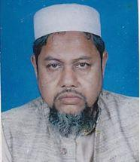 | DR. FAIZ AHMAD  F/Name: Late Jainal Abedin  M/Name:  BM & DC Reg. No:  NID:  Cell:  Address: Kauser Manzil, Raipur, Station Road Laxmipur.  Blood Group: n_a
5 | Voter No  LM-3400003  No Image | DR. PARESUL ALAM  F/Name: Late Mr. Wazi Ullah  M/Name:  BM & DC Reg. No:  NID:  Cell:  Address: Medical Officer Sadar Hospital Laxmipur.  Blood Group: n_a
6 | Voter No  LM-3400004  No Image | DR. MD. NURUL ISLAM  F/Name:  M/Name:  BM & DC Reg. No:  NID:  Cell:  Address: Consultant Paed.  Sadar Hospital.  Laxmipur.  Blood Group:
7 | Voter No  LM-3400005  No Image | DR. SALMA CHOWDHURY  F/Name: Shah Jalal Ali Chowdhury  M/Name:  BM & DC Reg. No:  NID:  Cell:  Address: Vill. Bancha Nagar,  P.O. & P.S.- Dist. : Laxmipur.  Blood Group:
8 | Voter No  LM-3400006  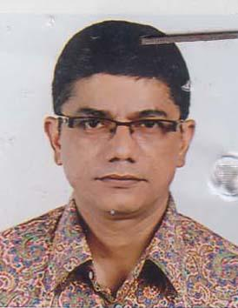 | DR. MD. ASHFAQUR RAHMAN  F/Name: Atiqur Rhaman  M/Name: Tajkera Begum  BM & DC Reg. No: 19263  NID: 5124308255199  Cell: 01712176226  Address: Model Hospital Pvt.  Ramgoti Road, Laxmipur.  Blood Group: A+
9 | Voter No  LM-3400007  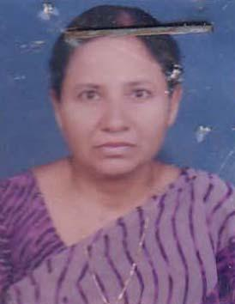 | DR. RUBINA YASMIN  F/Name: Md. Ramzan Ali  M/Name: Begum Sufia Ramzan  BM & DC Reg. No: 20983  NID: 5124306853997  Cell: 01711405520  Address: Baro- Belty, North - Temohoni Sadar, Lakshmipur  Blood Group: O+
10 | Voter No  LM-3400008 | DR. MD. AKHTER HUSSAIN  F/Name: Late Rashid Ahmed  M/Name: Late Noorjahan Begum  BM & DC Reg. No: 18659  NID: 5124306853997  Cell: 01711249282  Address: House- Banabethy, Dhaka Main Road North Tenubani, Dadar, Lakshmipur  Blood Group: O+
11 | Voter No  LM-3400009  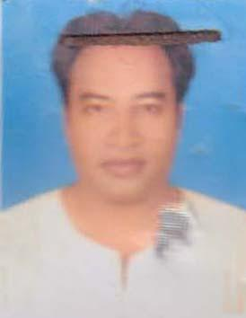 | DR. MD. FAZLUL KADER  F/Name: Md. Abdul Gafur  M/Name: Mst. Saleha Begum  BM & DC Reg. No: 38695  NID:  Cell: 01670370002  Address: C/O Abdul Gafur Manjil,  Azim Shah Road, Uttar Bazar  Laxmipur  Blood Group: A+
12 | Voter No  LM-3400010  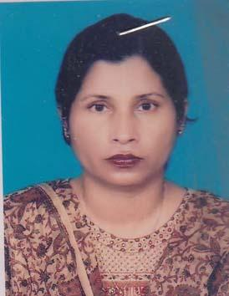 | DR. RUHITA MURSHED  F/Name: Late Abdur Razzaque  M/Name: Late Sufia Khatun  BM & DC Reg. No: 20392  NID: 1592827110948  Cell: 01199736661  Address: R/no-24, H/no-705 (3rd Floor), Agrabad, CDA R/A, Chittagong  Blood Group: A+
13 | Voter No  LM-3400011  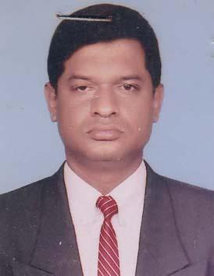 | DR. HABIB JALAL UDDIN AHMED  F/Name: Late Md. Nayeb Ali Mia  M/Name: Mrs. Setara Begum  BM & DC Reg. No: 20429  NID: 1592827110949  Cell: 01715173427  Address: House no-705, Rd no- 24, CDA R/A, Agrabad, Chittagong  Blood Group: B+
14 | Voter No  LM-3400012 | DR. MD. LOKMAN UDDIN AZAD  F/Name: Late. Nazir Ullah  M/Name: Late. Jobeda Begum  BM & DC Reg. No: 10804  NID: 5126503865228  Cell: 01711045530  Address: Director (Health) Dhaka Division, 105.106 Motijheel CA, Dhaka  Blood Group: B+
15 | Voter No  LM-3400013 | DR. A.K.M. MONINUDDIN  F/Name: Mohammad Moseeh  M/Name: Bilkis Malaya Khatun  BM & DC Reg. No: 19734  NID: 2690243845579  Cell: 01911323208  Address: Consultant Paediatrics  Sadar Hospital, Lakshmipur.  Blood Group: O+
16 | Voter No  LM-3400014  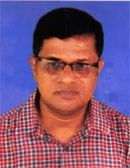 | DR. BHABANI PRASAD ROY  F/Name: LATE SUDHIR KUMAR ROY  M/Name: LATE INDRA KANA ROY  BM & DC Reg. No: 16082  NID: 2695045900201  Cell: 01711106157  Address: SENIOR CONSULTANT (CARDIOLOGY), SADAR HOSPITAL, LAKSHMIPUR  Blood Group: AB_po

